ELECENG 3EJ4
Lab. 5 Active Filter Circuits
Instructor: Dr. Chen
Jasmine Dosanjh – dosanj5 – 400531879
November 30, 2025

Part 1: First-Order Low-pass Filter

Q1. (20 Points)

(1) Find the transfer function of the first-order LPF, its low-frequency gain, and its -3dB frequency fc. (2) Compare the calculated low-frequency gain and the -3dB frequency fc with the simulated data from Step 1.3 and the measured data from Step 1.8, respectively. Justify/discuss the observation and comparison.
(1) Deriving the transfer function of the first-order LPF, its low-frequency gain, and its -3 dB frequency $f_{c}$:
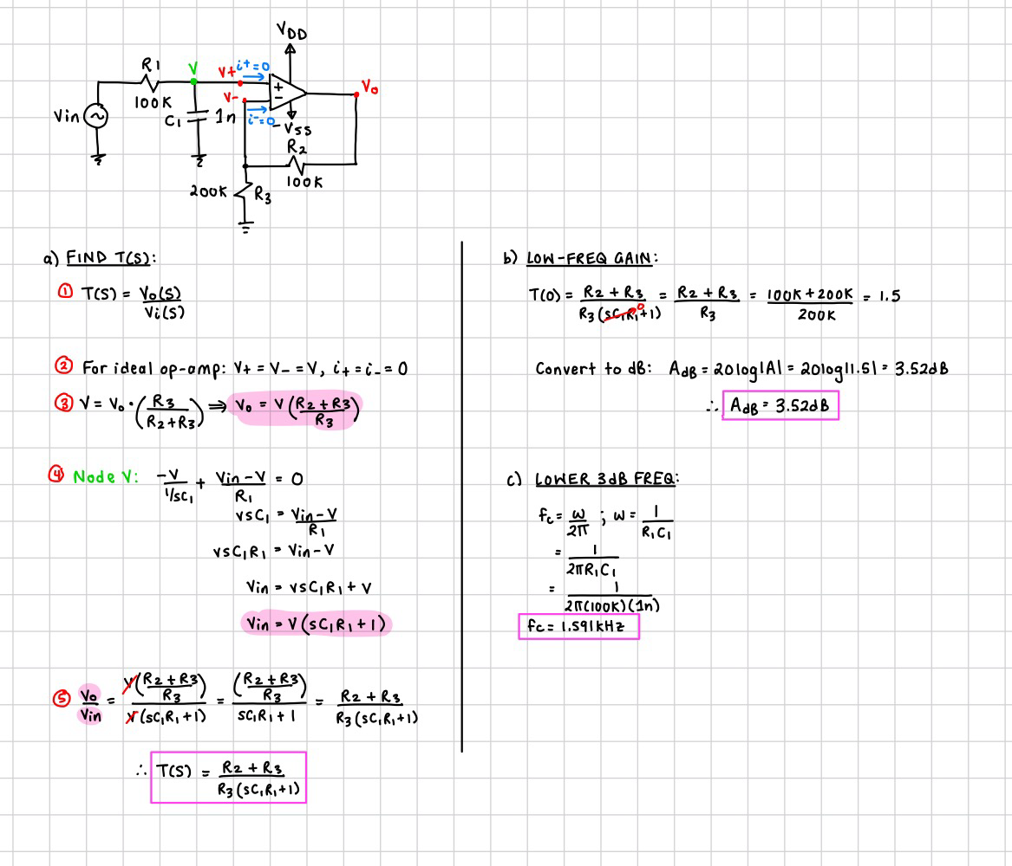

(2) Next we must compare the calculated low-frequency gain and the -3 dB frequency $f_{c}$ with the simulated data from Step 1.3 and measured data from Step 1.8.
Find Low-Frequency Gain:
Steps 1.3 and 1.8 gain is calculated by using the output voltage found below and the input voltage which is set to 100 mV:
Figure 1. Simulated and Measured Data for Gain

Step 1.3: $A_{v}=T\left(0\right)=\frac{V_{o}}{V_{in}}=\frac{0.15 V}{0.1 V}=1.5\frac{V}{V}=3.52 dB$
Step 1.8: $A_{v}=T\left(0\right)=\frac{V_{o}}{V_{in}}=\frac{0.1504 V}{0.1 V}=1.504\frac{V}{V}=3.54 dB$
Find -3 dB frequency $f_{c}$:
The -3 dB frequency $f_{c}$ is the frequency at which the amplitude becomes $\frac{1}{\sqrt{2}}=0.707$ of its low frequency value, or the phase changes $45°$. This gives us:
- Step 1.3: $V_{o}=0.707×0.15 V=0.1061 V ⇒f_{c}=1577.68 Hz$
- Step 1.8: $V_{o}=0.707×0.1504 V=0.1063 V⇒f_{c}=1672.99 Hz$
Figure 2. Simulated and Measured Data for fc
By observing Table 1 below, the simulated and measured data are similar to the data obtained in Part 1. The simulated data is closer to the ideal values since it’s also performed in ideal scenarios. It does not have external factors such as component tolerances, wire resistances, etc. Whereas, the physical measurement is subject to these errors, causing the measured values to have a higher deviation from the ideal values.
Table 2. Summary for Question 1 Part 2 Data
 | $A_{fL}$ (dB) | $f_{c}$ (Hz)
Calculation | 3.52 | 1591
Simulation | $$3.52$$ | 1577.68
Measurement | $$3.54$$ | 1672.99

Part 2: Second-Order Low-pass Filter

Q2. (20 Points)

(1) Derive the transfer function and calculate the low-frequency gain. (2) Verify the calculated gain using the simulated data obtained in Step 2.2 and the measured data obtained in Step 2.6, respectively.
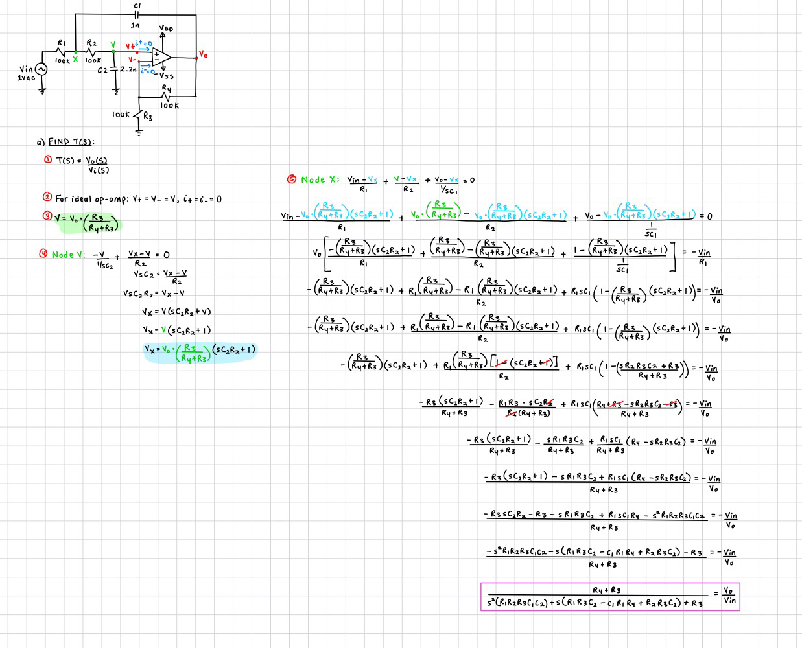
(1) Deriving the transfer function of the second-order LPF and its low-frequency gain:
Substituting the known quantities:
$$T\left(s\right)=\frac{R_{4}+R_{3}}{s^{2}\left(R_{1}R_{2}{R_{3}C}_{1}C_{2}\right)+s\left(R_{1}R_{3}C_{2}-C_{1}R_{1}R_{4}+C_{2}R_{2}R_{3}\right)+R_{3}}$$
$$T\left(s\right)=\frac{{2×10}^{5}}{s^{2}\left({2.2×10}^{-3}\right)+s\left(34\right)+{10}^{5}}=\frac{{9.09×10}^{7}}{s^{2}+s\left(1.55{×10}^{4}\right)+4.55×{10}^{7}}$$

Find Low-Frequency Gain:
Using the General Form of a 2nd-order Filter:
$$T\left(s\right)=\frac{a_{o}}{s^{2}+\left(\frac{ω_{o}}{Q}\right)s+{ω_{o}}^{2}}$$
The gain can be found by: $A_{v}=T\left(0\right)=\frac{a_{o}}{{ω_{o}}^{2}}=\frac{{9.09×10}^{7}}{4.55×{10}^{7}}=1.998 \frac{V}{V}=6.02 dB$
(2) Next we must compare the calculated low-frequency gain with the simulated data from Step 2.2 and measured data from Step 2.6.
Figure 3. Simulated and Measured Gain
All three methods provide a gain of approximately 6.02 dB, implying that the simulated and measured data align closely with the calculated gain in Part 1.

Q3. (20 Points)
Calculate (1) the pole frequency fo, (2) the cut-off frequency (or -3dB frequency) fc, (3) the pole quality factor Q, (4) the peak value of the magnitude of the transfer function, |T(s)|max, and (5) the frequency fmax where the peak value of the magnitude of the transfer function happens. Verify the calculated fc using the simulated data obtained in Step 2.2 and the measured data obtained in Step 2.6, respectively.

(1) The pole frequency $f_{o}$ is found below:
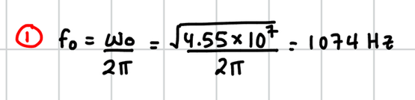
(2) The cutoff (-3 dB frequency) $f_{c}$ is the frequency at which the amplitude becomes $\frac{1}{\sqrt{2}}=0.707$ of its low frequency value. This gives us:
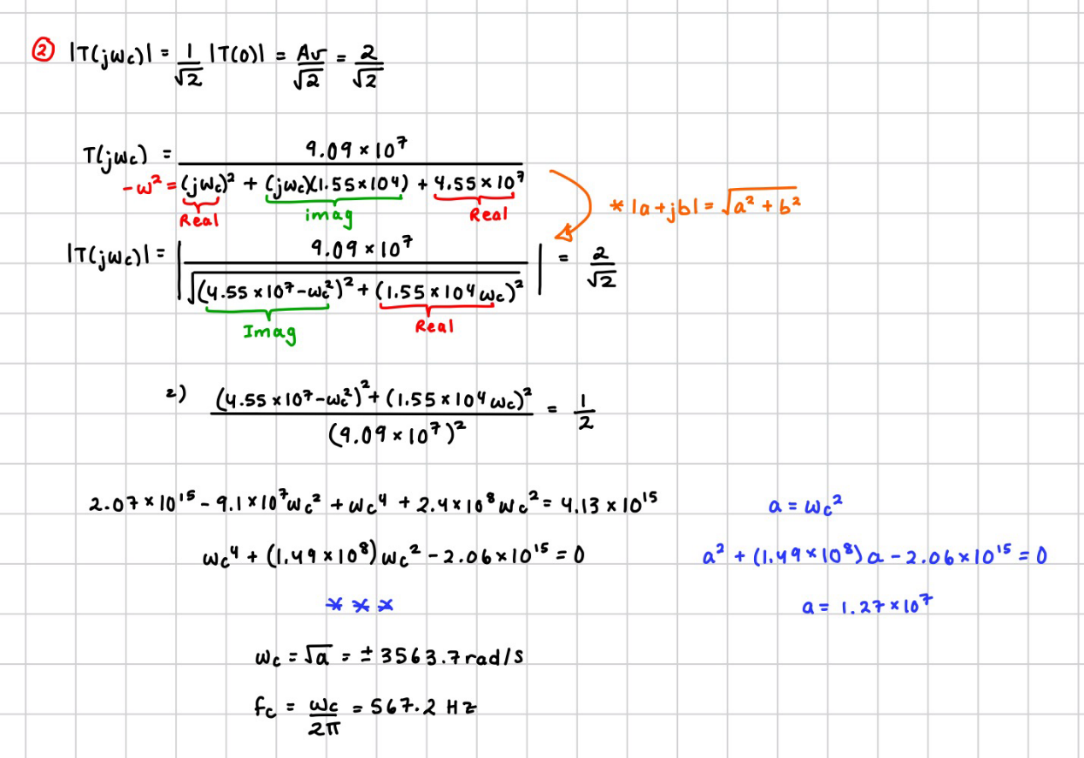
Verifying fc using data obtained in Step 2.2 and Step 2.6:
The calculated cutoff frequency $f_{c}=567.2 Hz$ occurs at a cutoff gain of:
$$A_{c}=20log\frac{2}{\sqrt{2}}=3.01 dB$$
Figure 4 shows that all three methods corresponding to this cutoff frequency occur a gain of approximately 3.01 dB, implying that the simulated and measured data align closely with the calculations above.
Figure 4. Simulated and Measured Cutoff Frequency
(3) The pole quality factor Q is found below:
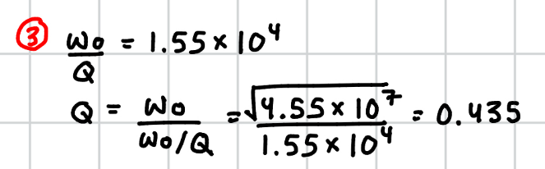
(4) The peak value of the magnitude of the transfer function ${\left|T(s)\right|}_{max}$ is found below. Since $Q<\frac{1}{\sqrt{2}}$, the system has no bump at the pole frequency, and thus the maximum is at DC where $ω=0$:
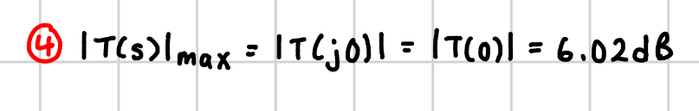
(Same as Q2 Part 1)
(5) The frequency $f_{max}$ where the peak value of the magnitude of the transfer function happens occurs at 0 Hz ($ω=0)$. This value then drops at the pole frequency $f_{o}=1074 Hz$.
This can be verified by observing the simulated data from Step 2.2 (Figure 4) and measured data from Step 2.6 (Figure 5). The peak of the Transfer function occurs at 0 Hz, with a gain of approximately 6.02 dB. This gain stays constant until the pole frequency is reached around 1074 Hz.
Figure 4. Step 2.2 Simulated Transfer Function
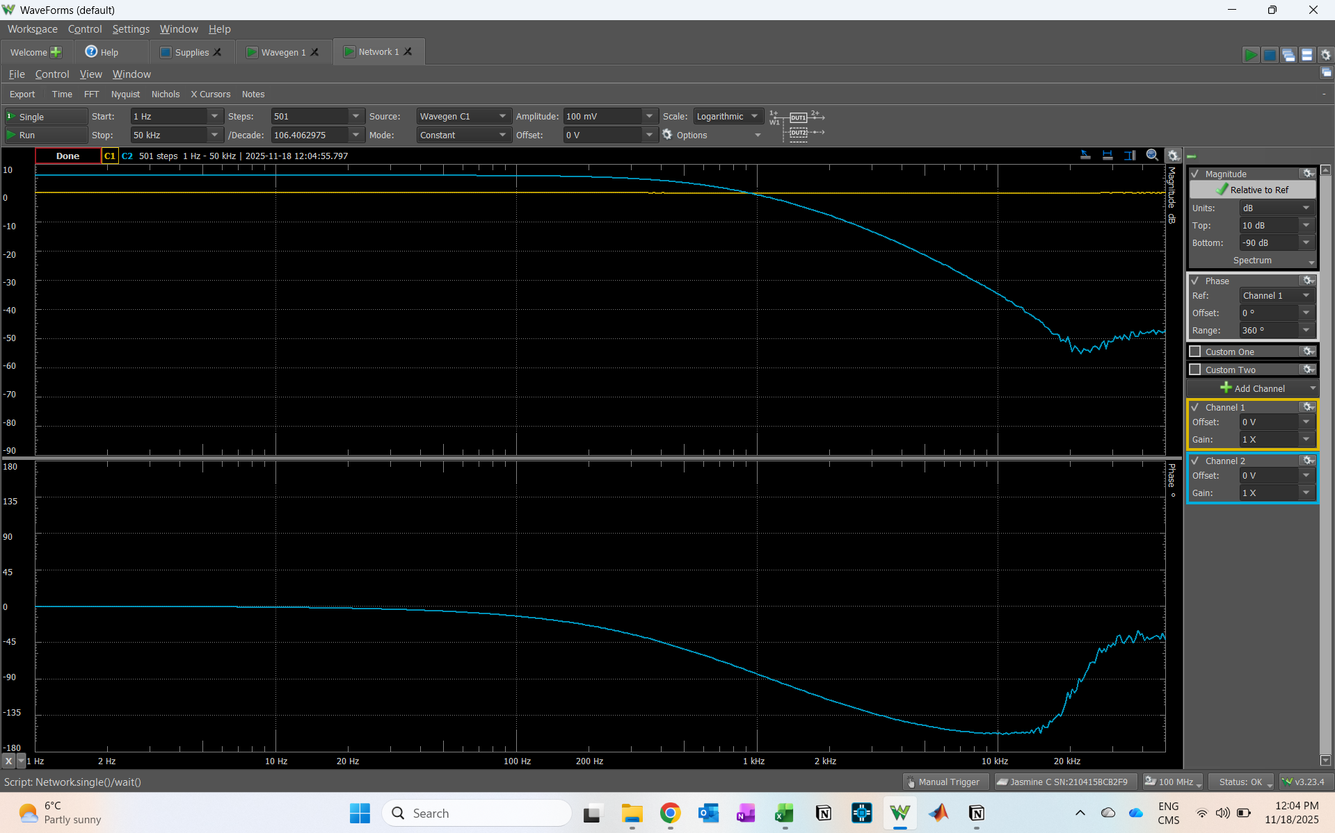
Figure 5. Step 2.6 Physical Implementation of Transfer Function

Part 3: Second-Order Bandpass Filter

Q4. (20 Points)
(1) Derive the transfer function and calculate the center frequency gain. (2) Verify the calculated gain using the simulated data obtained in Step 3.2 and the measured data obtained in Step 3.6, respectively.
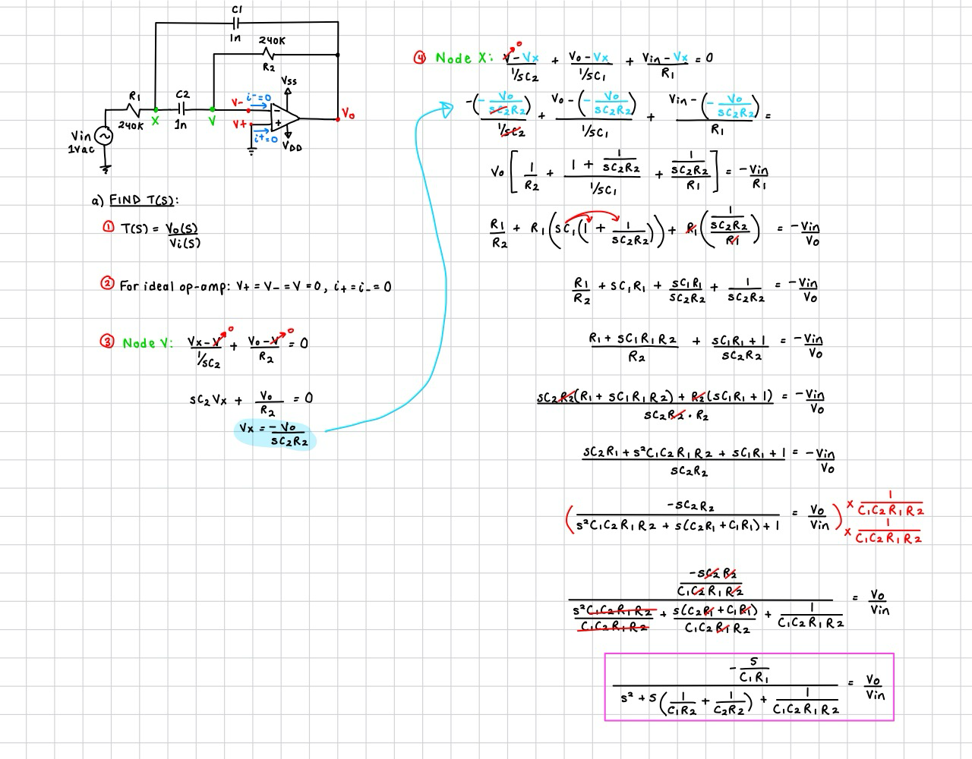
(1) Deriving the transfer function of the second-order BPF, and center-frequency gain:
Substituting the known quantities:
$$T\left(s\right)=\frac{-\frac{s}{C_{1}R_{1}}}{s^{2}+s\left(\frac{1}{C_{1}R_{2}}+\frac{1}{C_{2}R_{2}}\right)+\frac{1}{C_{1}C_{2}R_{1}R_{2}}}$$
$$T\left(s\right)=\frac{-s(4.167×{10}^{3})}{s^{2}+s(8.3×{10}^{3})+1.74×{10}^{7}}$$
Find Center-Frequency Gain:
$$ω_{o}=\sqrt{1.74×{10}^{7}}=4.171×{10}^{3} rad/s$$
$$f_{o}=\frac{ω_{o}}{2π}=663.89 Hz$$
The gain can be found by:
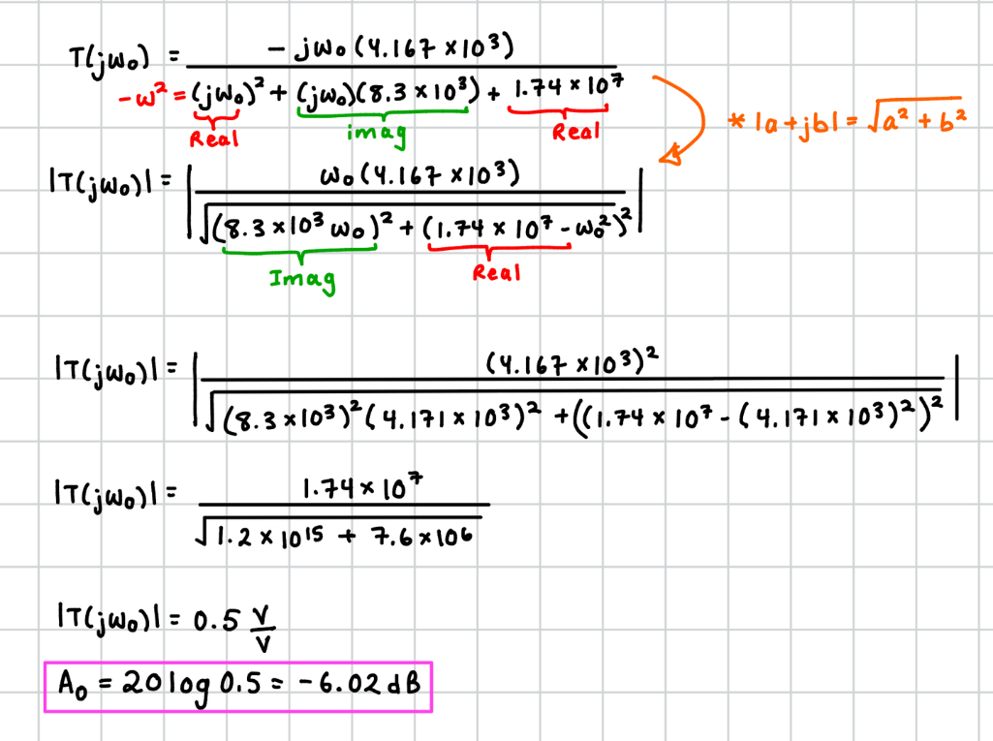

(2) Verifying gain using the Step 3.2 and in Step 3.6 data:
Next we must verify the calculated low-frequency gain with the simulated data from Step 3.2 and measured data from Step 3.6.
Figure 6. Simulated and Measured Gain
All three methods provide a gain of approximately -6.02 dB at $f_{o}≈663Hz$, implying that the simulated and measured data align closely with the calculated gain in Part 1.

Q5. (20 Points)
Calculate (1) the center frequency ωo, (2) the pole quality factor Q, (3) the two -3dB frequencies ω1 and ω2, and (4) the 3-dB bandwidth BW = ω2 - ω1. Verify the calculated results
(1) The center frequency $ω_{o}$ is found below:
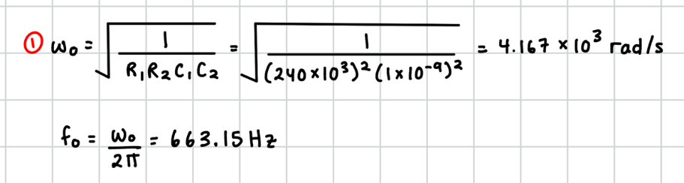
(2) The pole quality factor Q is found below:
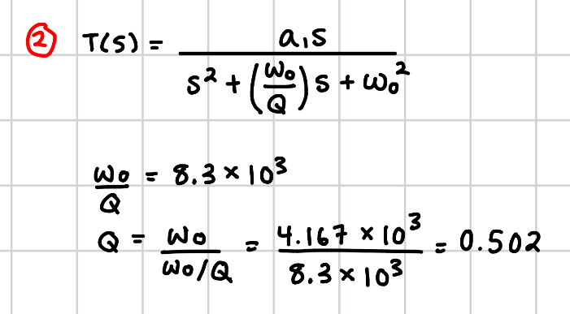
(3) The two -3dB (cutoff) frequencies $ω_{1}$ and $ω_{2}$are the frequencies at which the amplitude becomes $\frac{1}{\sqrt{2}}=0.707$ of its low frequency value. This gives us:
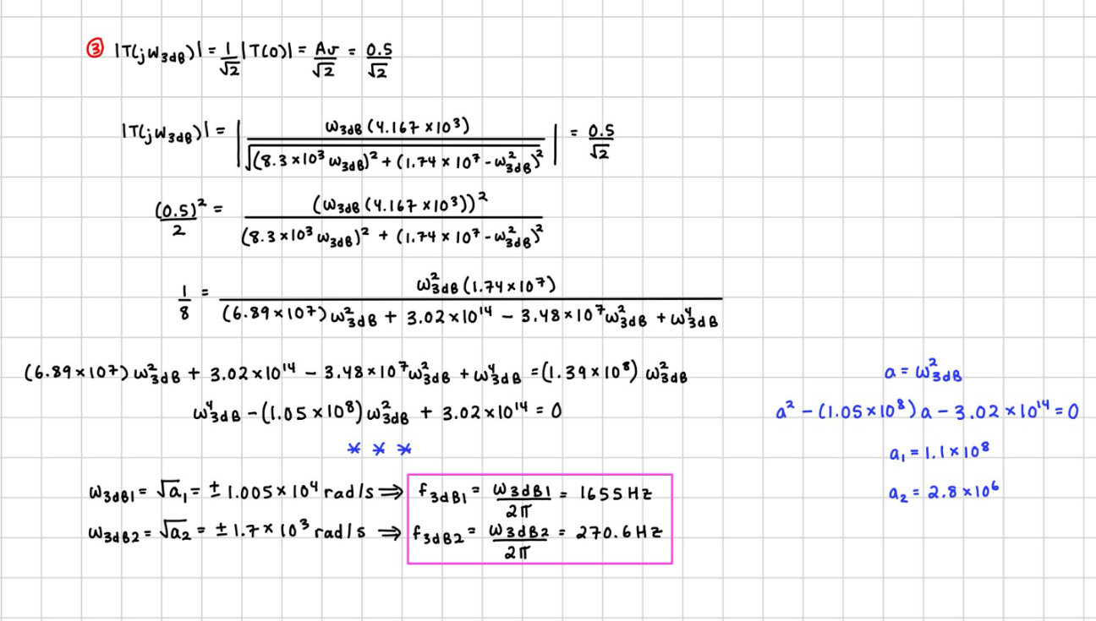
(4) The 3-dB bandwidth is found below:
$$BW=ω_{1}-ω_{2}=1.005×{10}^{4}-1.7×{10}^{3}=8.3×{10}^{3} rad/s$$

Verifying the calculated results
The calculated cutoff frequencies occur at a cutoff gain of:
$$A_{c}=20log\frac{0.5}{\sqrt{2}}=-9.03 dB$$
Figure 7 shows that all three methods corresponding to the cutoff frequencies, occur at gain of approximately -9.03 dB, implying that the simulated and measured data align closely with the calculations above. The simulated data is closer since it’s performed in ideal scenarios. It does not have external factors such as component tolerances, wire resistances, etc. Whereas, the physical measurement is subject to these errors, causing the measured values to have a higher deviation from the ideal values.
Figure 7. Simulated and Measured Values

